Economics Project: How knowledge of Technology and Engineering can improve lives in Slums



**Partners in Crime:**

## Aviral Sharma: 2k16/MC/024

## Ashish Gupta: 2k16/MC/023

## Ahmad Javed: 2k16/MC/008 --< see

## Manit Jindal: 2k16/MC/041 --< see

## Anish Sachdeva: 2k16/MC/011

Table of Content

// This is going to be a table , with page numbers and serial wise with a brief description. It looks //cool so that mam don’t have to read all the project. She will be comfortable checking project here //only☺

[ Introduction ( Data showing Life expectancy and Death rate, advancement in engineering)

Problems we saw in Slums(Images come here with a very brief description) ]( 3 pages)

Suggested Solutions for Life Transformation: (2-3 pages)

Going solar: Topic 1__

Going Solar: Topic 2__

Water Sanitation and Water Scarcity(2-3 pages_)

Topic 1__

Topic 2__

Pollution and Waste Disposal(2-3 pages)

Use of Advanced Machine Learning in Predicting droughts and where solar can be set, to maximize profits and reach.(1 page_)

Conclusion: Yes lives can be improved and the proposed solutions are cheap:

Here : include Cost Summary, and How pollution will be reduced.

Slums and Problems

Wikipedia describes a slum as “a squalid and overcrowded urban street or district inhabited by very poor people”. Naturally, there are many problems that we people face in slums due to the very nature of the dwellings. We sought to find those out, hence we visited Haidarpur slum at the outskirts of Delhi, near Badli Metro Station. The very spectacle of poor living and the potential of improvement left a mark on us.

We noticed the following problems when we reached the slums.

Poor Sanitation and No waste disposal

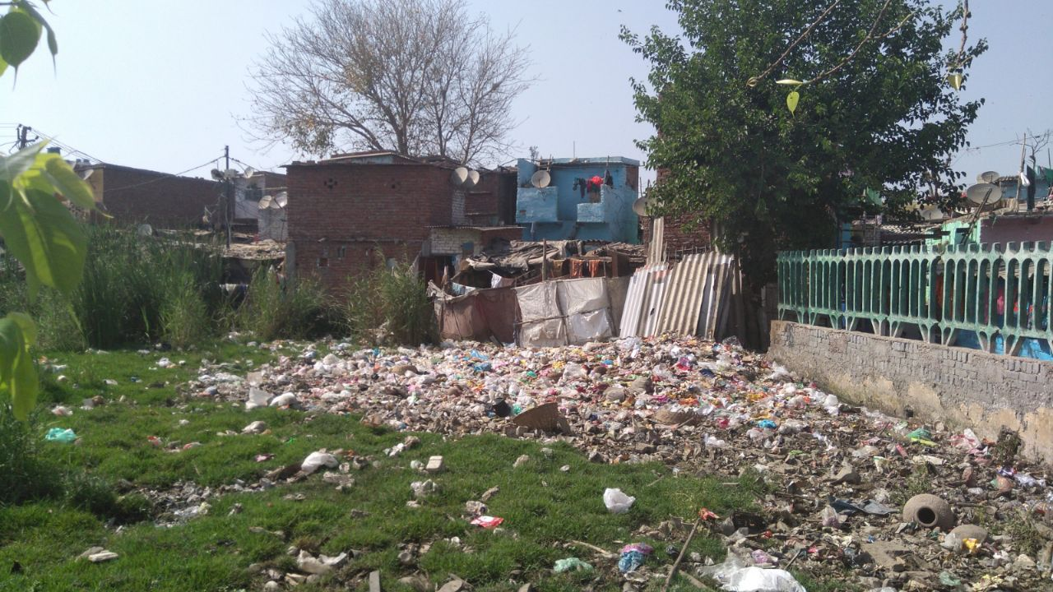

[Pic Credits: Aviral Sharma, Ashish Gupta]

This area was in the centre of the slum. Problems associated to this are not too uncommon these days. Places like these are the favourite dining table for mosquitoes and breeding ground for Dengue, Malaria, and Jaundice etc. The smell of this filth is also annoying.

# **poor Water Management, Water, Electricity Scarcity**

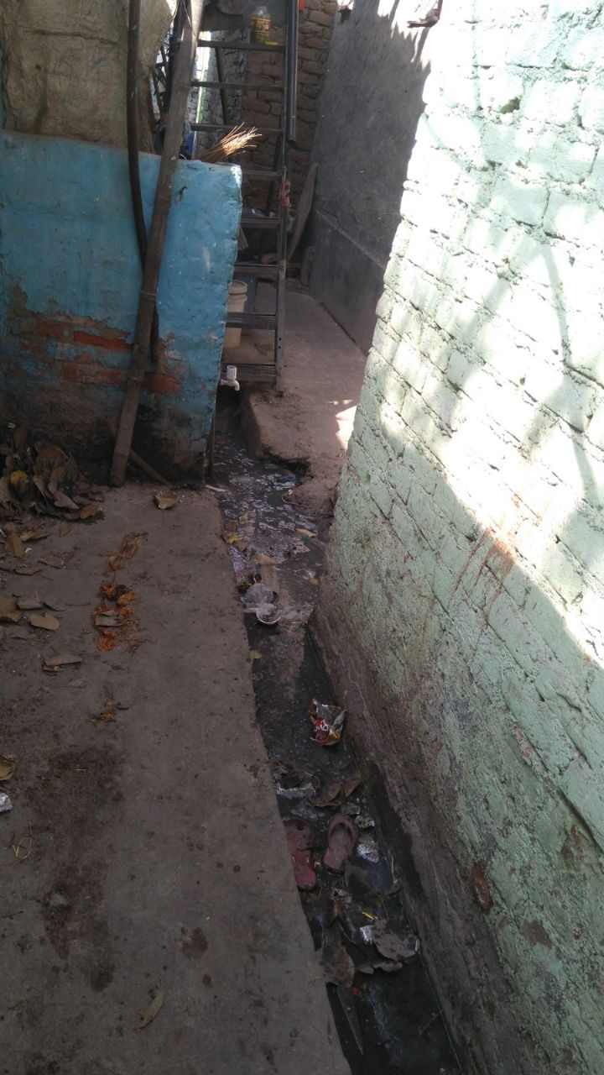This Drain was completely chocked. One rain and it floods. Some wont believe but this goes just outside the houses of many people. The enterance of their houses is met by this drain. Naturally, it is breeding ground for mosquitoes

[Pics: Manit Jindal and Ahmad Javed]

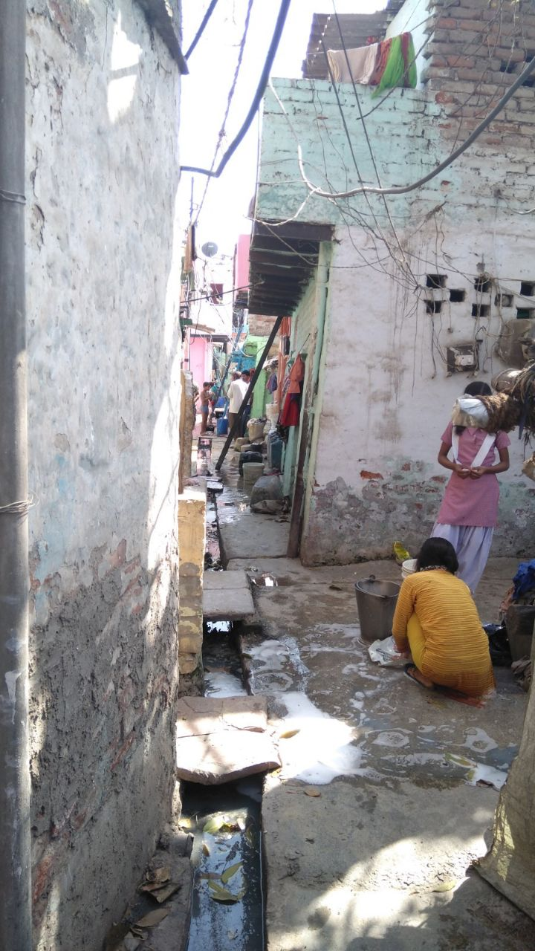

Talking to these women, we came to know about the poor quality of water and acute shortage of drinking water. The water and electricity is highly irregular. This creates a drastic problem for kids who can’t study in dim lighting of slums and obviously cooking needs of women. The water comes through tankers in these areas, far from home and hours of fight to secure it.

Other problems Include:

**POOR STRUCTURAL QUALITY AND DURABILITY OF HOUSES**

Poor quality and overcrowded housing in slums has a significant impact on people's

lives. Poor housing means diseases spread more easily, the effect of disasters like

flooding are amplified, and people are denied their privacy and safety.

**INSUFFICIENT LIVING AREAS**

More number of people living in one room. They live in congested areas with thin

lanes, no drainage facilities.

**LACK OF SECURE TENURE**

People are not certain about their existence in the slum they are living as they may

be asked to leave it any time further worsening their lives.

**Effects on lives of people due to this:**

**Due to lack of proper Education/hygienic environment/ good quality food not only the physical, the mental ability and childhood of the young ones in the slum children is vanishing.** Their non-trivial tribulations force them to do the work at very early ages like rag picking and small shop keepings etc. The worst part is that some of the misguided people used to do the partially criminalistics works due to bad environment and lack of money for their very basic daily needs.

**Apart from that the biggest problem is they live in houses that are not authorized by the government due to which they have to suffer** when any kind of commercial government projects implemented in their area and they are made to leave their land forcibly.

Usually in the areas they live**, at the season of raining the major part of their land is covered with water** and sometimes due to heavy raining the situation become that much worse that the water is collected inside their houses.

Proposed Solutions through Engineering and Technology

Other than infrastructural problems, the people in slum suffer from lack of clean water and they clearly lack electricity. In order to improve life of poor people in Slums we have come up with various ground breaking solutions that are cheap and easily implemented in slums to improve the lives of people in slums.

Following can be done:

1. Going Solar on Electricity and Cooking needs.
   1. Solar Bottles for lighting the houses
   2. Use of solar water ATM’s for Cheap Drinking Water
2. Tackling Water shortage needs and Water Sanitation problems

2.1) Solving Water Shortage Problems (this needs editing)

2.2) Solving Water Sanitation Problems(This needs editing)

3) Use of State of the Art Machine Learning Techniques to solve problems.

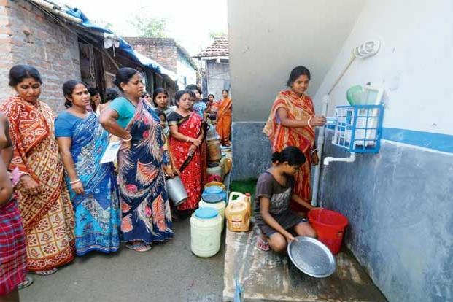

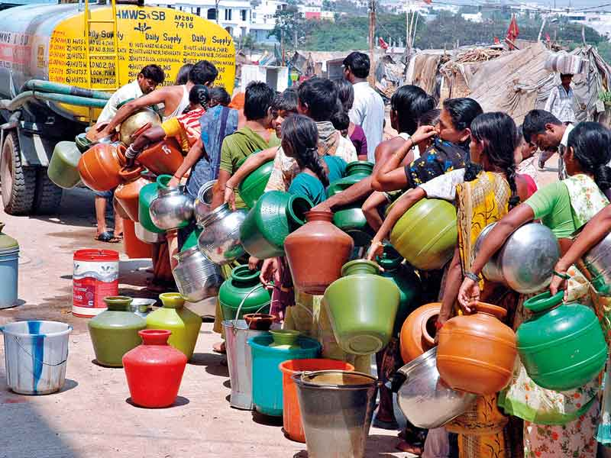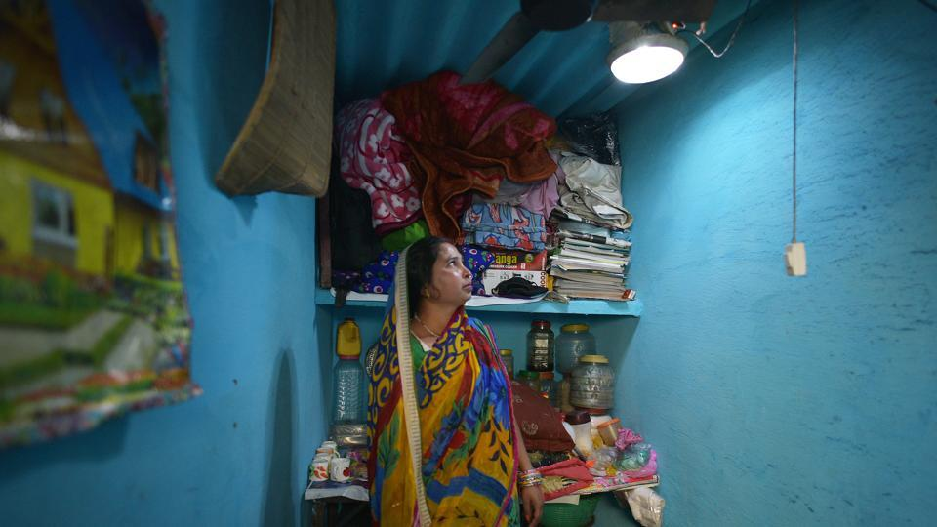

1)Going Solar is the Way!

Solar Water Bottle Bulbs- A Litre of Light at a time:

<https://www.hindustantimes.com/delhi-news/solar-domes-transforms-lives-in-a-delhi-slum/story-BHomXjZcIylTw5rZEIPnwO.html>

[https://www.teatime-mag.com/magazines/31-de](https://www.teatime-mag.com/magazines/31-de/)

What are the main problems in lighting slums, low/ no electricity and not much money to spare. Comes to rescue, SOLAR BOTTLES. Developed for Slums in Phillipenes by MIT, this offers revolutionary way to light the home.

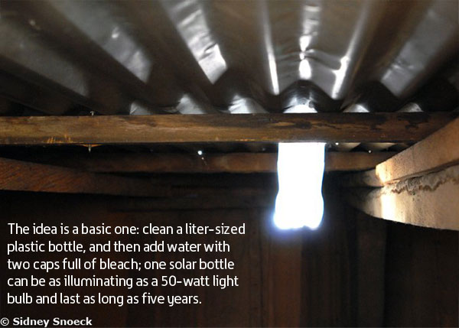

**Advantages and Cost:**

As a cost-effective alternative to electricity, **the solar bottle only costs about 120 Rs** to make and a few minutes to install. In addition to its immediate effects for lighting in the developing areas, it also presents an opportunity for economic empowerment. “The bottles are a free resource, and the corrugated metal and caulkis all you need,” Barrie added. “Someone could provide this at a relatively low cost, and people can make a little bit of money.”

Another appealing aspect of this solution to affordable lighting is the fact that they are easy to replicate. Solar bottle bulbs do not require factory-made parts that will be difficult to maintain, and making the bottle is a process that almost anyone can learn to do.

Overall, the solar bulb’s greatest impact may be what it represents changing global community where even **economically disadvantaged can access the tools they need to help one another**. “The beauty of it is that people are starting to solve their own problems. It’s creating a net public good through social media.”

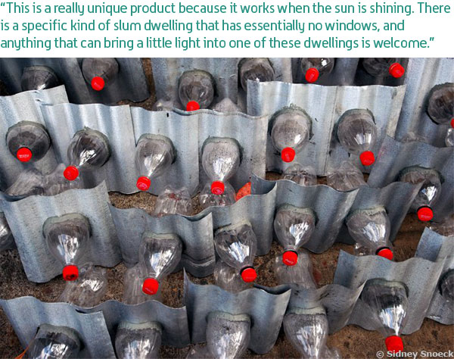

Believe it or not, they are absolutely functional and powering houses on recycled bottles in Philippines, source - <https://www.teatime-mag.com/magazines/31-de>

We were equally mesmerized to discover this.

<https://yourstory.com/2017/12/janajal-water-atms/>

Solar Water ATMs, The clean, cheap water dispensing machines!

Another major problem in slums is that although we have abundant sunlight and sometimes electricity is also there, but water is just not there. Thousands of people having pots in hands and heads wait in line for water. No more!

The United Nations recognises access to clean water as a basic human right. India is, however, home to over 16 crore people who don’t have access to water. More than a fifth of all communicable diseases in India are spread due to unsafe water and lack of hygiene. According to [water.org](https://water.org/our-impact/india/), over 500 children in India die every day due to lack of safe drinking water.

Idea:

The basic idea is to install water purification ATMs in every block of a slum, as they take up least amount of space. Connect a pipe through rain water/ government supply and you have purified water at 1 Re a Liter.

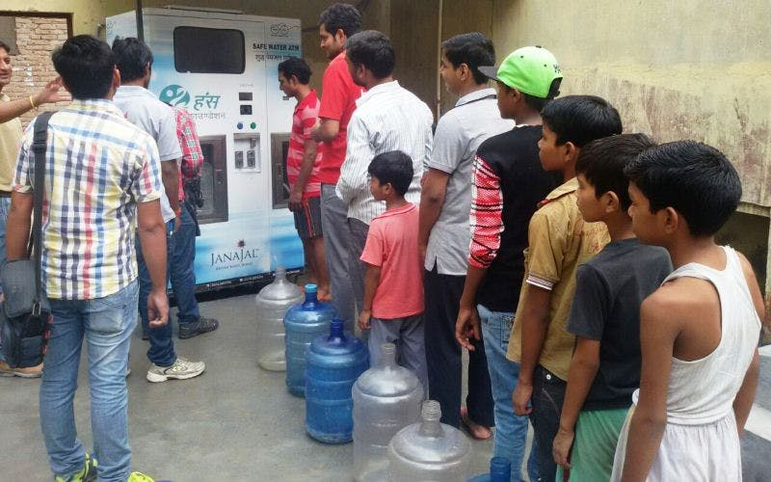

**Advantages and Cost:**

ATMs can operate on both regular electricity supply as well as solar power. They are highly configurable on a need-basis. Pricing for a liter of chilled water is Rs five, which is considerably lesser than bottled water, and does not carry disposable plastic bottle footprint. This can be reduced drastically to as low as Re one per litre for dispensing volumes in multiples of 20 litres when it comes to serving communities living in urban slums and residential colonies.

The social enterprise remotely monitors all the ATMs using cloud-based IT infrastructure. “The cloud-based system works in real time. It not only provides dispensing data but also system health, purity level of water dispensed, and enables us to ensure smooth functioning of the system.”

**Currently, every water ATM caters to approximately 800-1,000 persons per day. This is expected to rise exponentially over the next five years.**

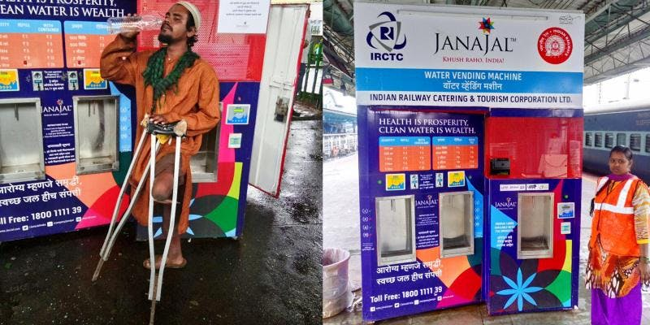

**Believe it or not,** The idea is being implemented since 2013, in Gujrat, Maharashtra by the company named JANJAL(see the picture). It has catered to over 3 Lakh people till now on daily basis.